Project Initialization and Planning Phase

Team ID | MCA
Project Name | Smartphone Usage, Digital Addiction & Well-Being Analytics
Maximum Marks | 3 Marks

Problem Statements
The organization needs to understand why 5,308 of its 7,500 users (70.77%) are classified as addicted to smartphone usage, and which factors — screen-time behavior, lifestyle habits, stress, or demographic characteristics — most strongly correspond with that classification. Without this understanding, product and research teams cannot prioritize well-being feature investment or design targeted digital-health interventions.
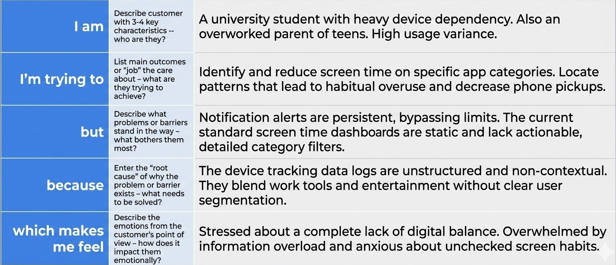
Example: 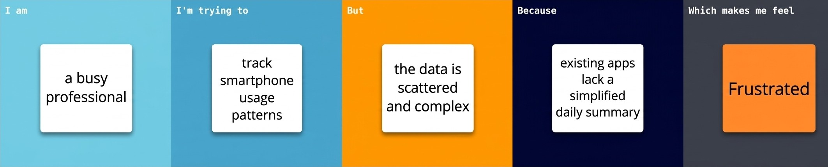

Problem Statement (PS) | I am (Customer) | I'm trying to | But | Because | Which makes me feel
PS-1 | A busy working professional or student | Maintain a healthy digital balance and reduce screen time | I constantly get distracted by endless scrolling and notifications | Apps are intentionally designed to maximize engagement and lack strict self-control tools | Anxious and unproductive due to lost time
PS-2 | A parent tracking family wellness | Understand and manage my child's daily device usage trends | The built-in tracking logs are scattered, complex, and lack actionable insights | Existing metrics show raw time data without context on productivity vs. entertainment | Overwhelmed and concerned about unchecked digital habits

